Name:Arundarasi Rajendran

PRN: 18070122081

Batch: C4

**Assignment 4**

**Cal sal of employee where salary is base payment +hra and if employee belongs to more than supervisor category then he will get additional sal of 5000 else +2000**

CODE on NANO

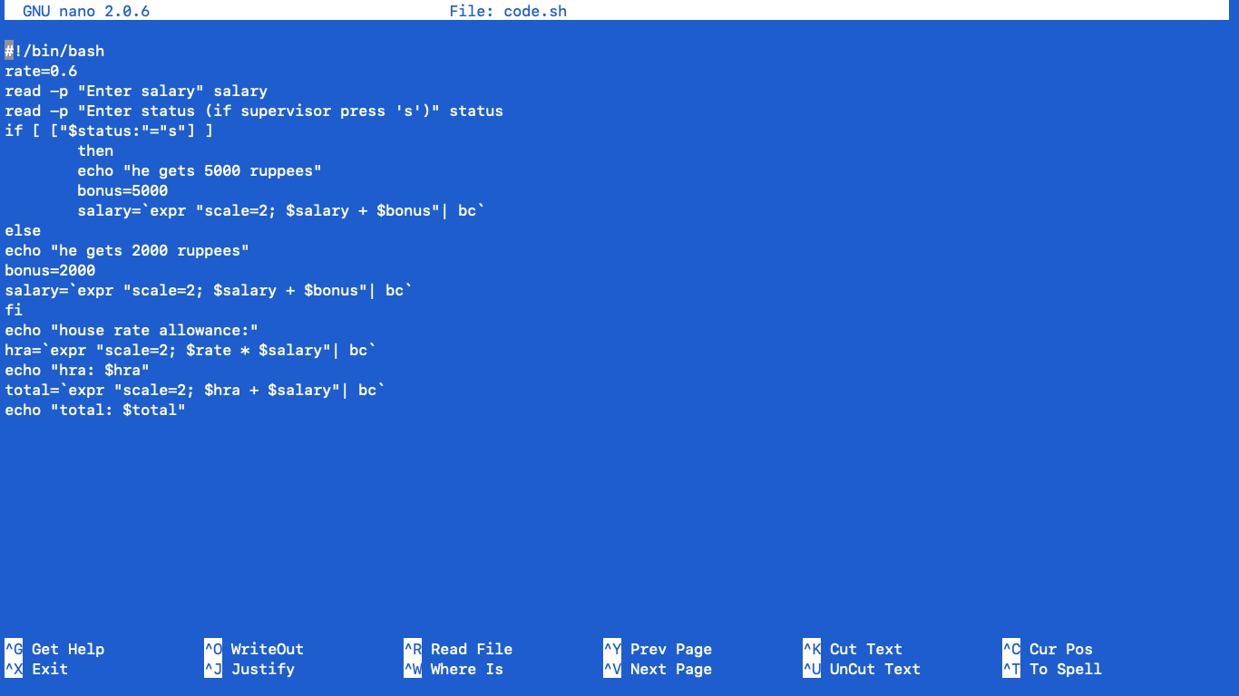

Output on terminal



**WAP to find area of triangle ,square, rectangle to and circle**

Program code

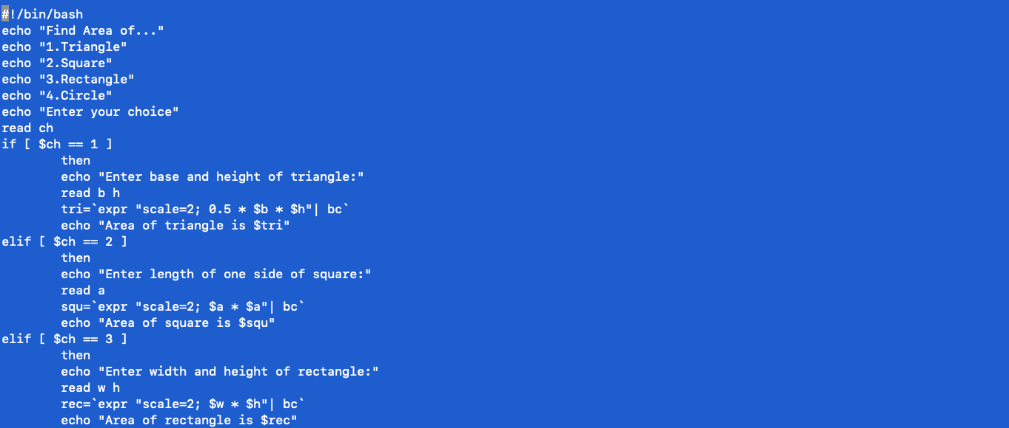



Output





**WAP to calculate simple interest**

Program code

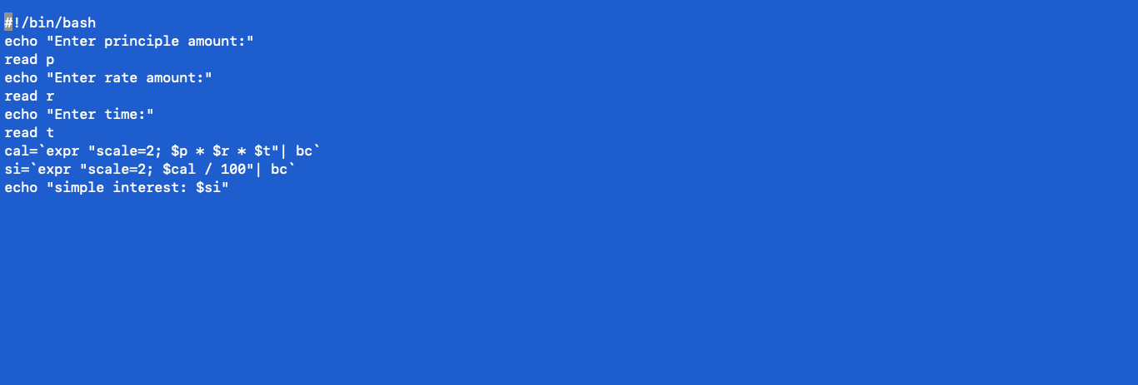

Output

